**Project Design Phase-II Data Flow Diagram & User Stories**

|  |  |
| --- | --- |
| Team ID | PNT2022TMID05962 |
| Project Name | Project - Personal Expense Tracker |
| Maximum Marks | 4 Marks |

**Data Flow Diagrams:**

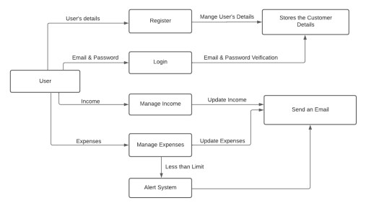

**User Stories**

|  |  |  |  |  |  |  |
| --- | --- | --- | --- | --- | --- | --- |
| **User Type** | **Functional**  **Requirement**  **(Epic)** | **User Story**  **Number** | **User Story / Task** | **Acceptance criteria** | **Priority** | **Release** |
| Customer (Web user) | Registration | USN-1 | As a user, I can register for the application by entering my email, password, and confirming my password. | I can access my account / dashboard | High | Sprint-1 |
|  | USN-2 | As a user, I will receive confirmation email once I have registered for the application | I can receive confirmation email & click confirm | High | Sprint-1 |
|  | Login | USN-3 | As a user, I can log into the application by entering email & password | I can access all the feature | High | Sprint-1 |
|  | Dashboard & Logout | USN-4 | As a user, once I logged in I can access all the features of the web app and Logout once I completed all the work. | I can access all the feature and shut it down once logged out | High | Sprint-1 |
|  | USN-5 | Once logged In, Keep me logged for few hours to avoid repeated login if the page is refreshed | I can remain logged in if the page refreshes | Medium | Sprint-1 |
|  | Expense | USN-6 | Add total income for the month and Allow for edit option | I can add Total income and edit if it changes a lot | High | Sprint-2 |
|  | USN-7 | Split the total income based on usage like entertainment, food, shopping etc. | I can split it as per the  usage | Low | Sprint-2 |
|  | USN-8 | Add the day to day expense. | I can add the income and expense data along with label | High | Sprint-2 |
|  | USN-9 | Display the user added expense | I can see the past expense along with pending balance | High | Sprint-2 |
|  | USN-10 | Filter the expense data based on criteria | I can filter the past data with custom data and type | Medium | Sprint-3 |
|  | Show charts | USN-11 | As a user I can display it in graphs | I can see the bar, pie chart etc | Low | Sprint-3 |
|  | Show alerts | USN-12 | As a user I create custom alert for the balance | I should receive mail once the level reached below | High | Sprint-3 |
|  | Deployment | USN-13 | As a user I should able to access it anywhere in the net | I should access the site from any device | High | Sprint-4 |